LOCATIONS OF FREEDOM CAMPING SITES AND FACILITIES

These are the three remaining freedom camping sites open for self-sufficient campervans. If you do not have a self-sufficient campervan (with your own shower and toilet) you need to arrange temporary accommodation. Please call the Temporary Accommodation Services on 0508 754 163 for help. If you are not sure what to do in your situation you can also call our local helpline
on 0800 884 222.

Tauranga - Marine Park Freedom Camping Site

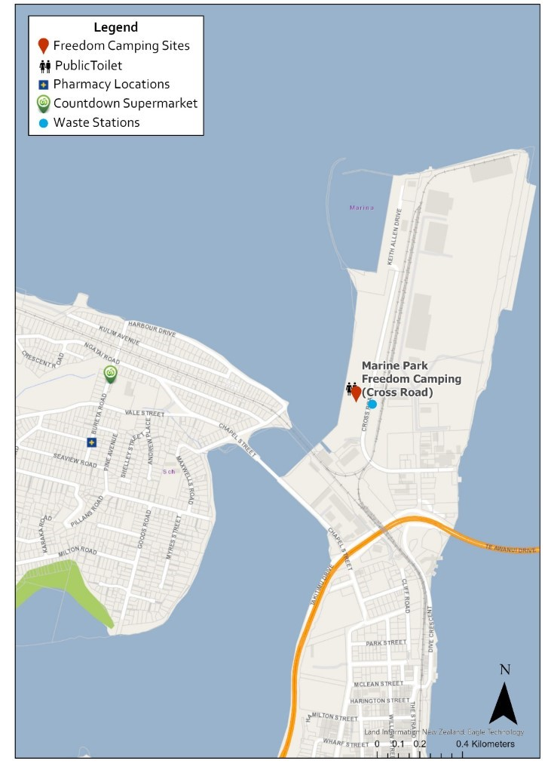

Te Puke - Commerce Lane Car Park Freedom Camping Site

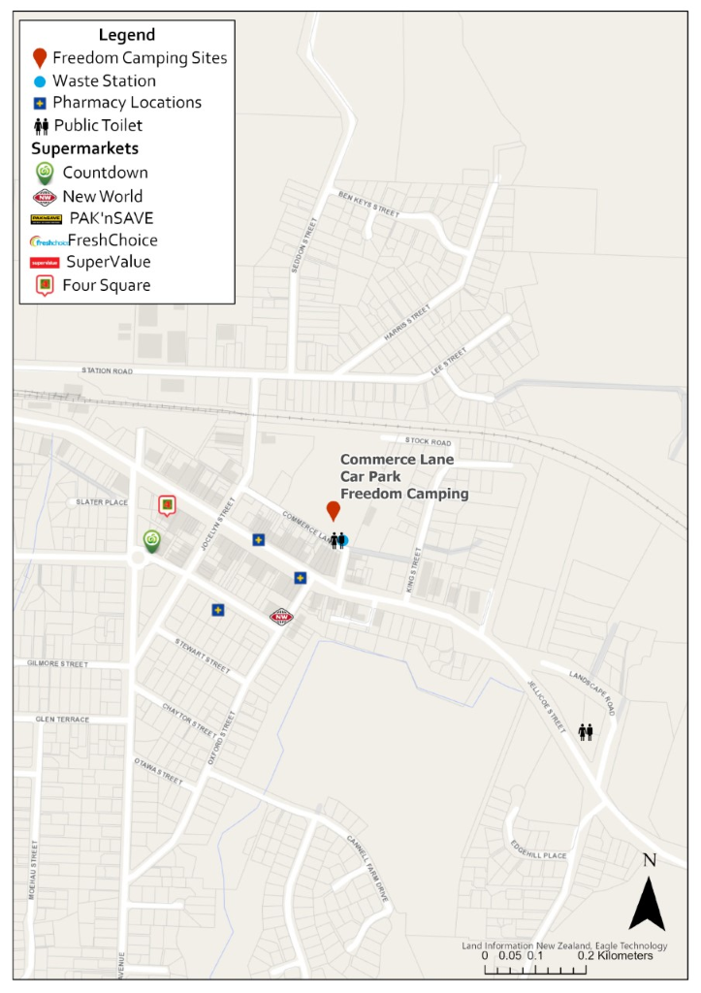

Katikati - Uretara Domain Freedom Camping Site

